

**Alpaca worm count installation instructions.**

 Note: If you already have installed ‘**Alpaca worm count database’** then do not use these instructions. Updates can be installed from the ‘**About’** page in the software. These instructions are for a new installation.

Download link is at <http://mullacottalpacas.com/aig/WDB.html>

The installation process is in three parts

1. Download the .zip file form Mullacott Alpaces web site
2. Unzip the file downloaded to drive C:
3. Install the Alpaca worm count software

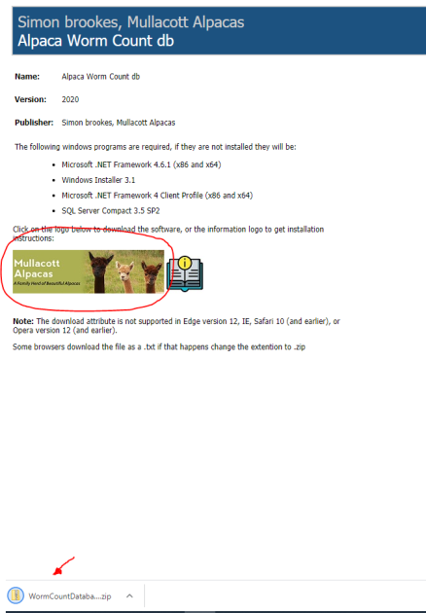Step 1 - click on the link to download the software. Depending on your machine and browser you will be asked to ‘**open’** or ‘**save’** the download, choose the ‘**save’** option. Wait until the browser reports that it has finished the download. If the browser reports that it is unsafe then ignore this and give the browser permission to download.

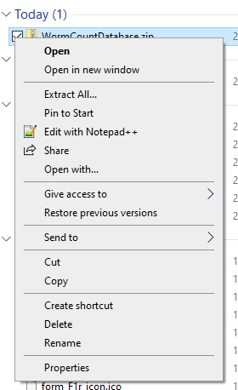Step 2 - When the download is complete open your download folder and right click on the download which should be called ‘**WormCountDatabase.zip’** and choose the ‘**Extract All…**’ this will ask for the ‘**Destination folder’** change this to C:\ then click the ‘**Extract’** button.

Step 3 – When the .zip files have been extracted and saved to C:\ there should be a folder on your machine C:\WormCountDatabase. Open this folder and double click on ‘**setup.exe’** The program will check your machine to see if it has all the Microsoft components if not it will try to get them form the Microsoft web site. During the process the machine might have to reboot. Also if you have any fire walls or security it might ask you to give permission to install. 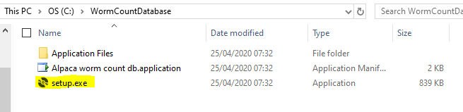

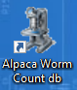

A desktop icon will be added for you to start the software.